Laboratory Assignment 10: Counters
ECE 0201: Digital Circuits and Systems
(50 Points)
Name
张鹤扬 Stefan Zhang
Submission Checklist:
Write within boxes, do not move boxes
Write your full name in the box above
Save this file as a PDF before uploading, keep the number of pages (9) unchanged
Note “TO BE CONTINUED” in the answer box if you used the extra pages (8-9)

Part I: Design of Synchronous Counters Using Behavioral HDL (5 points)
[(A) Insert a screenshot of your VHDL code for Part I.] (1 points)
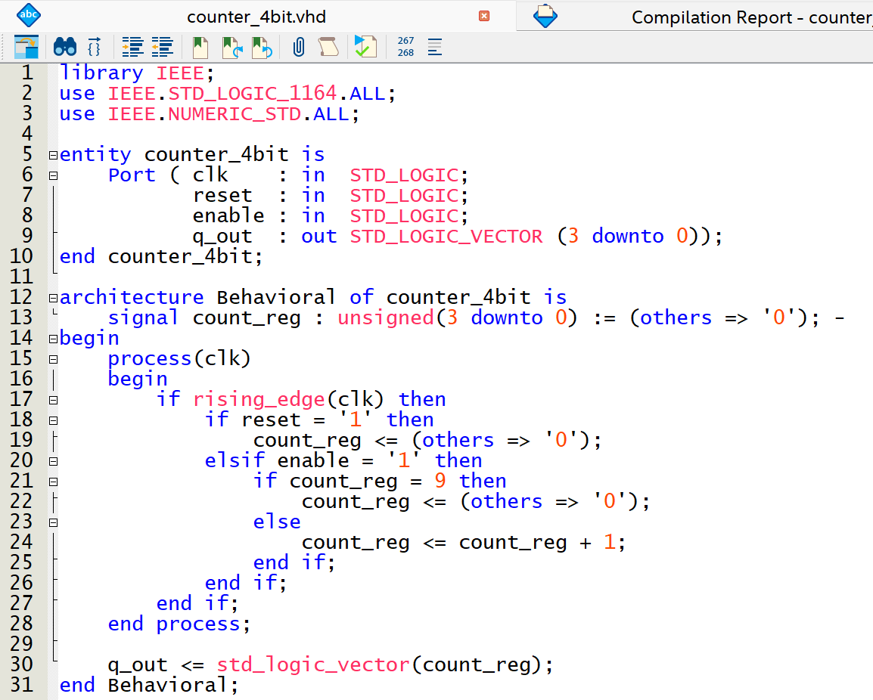

[(B) Insert a screenshot of your RTL Viewer schematic for Part I.] (2 points)
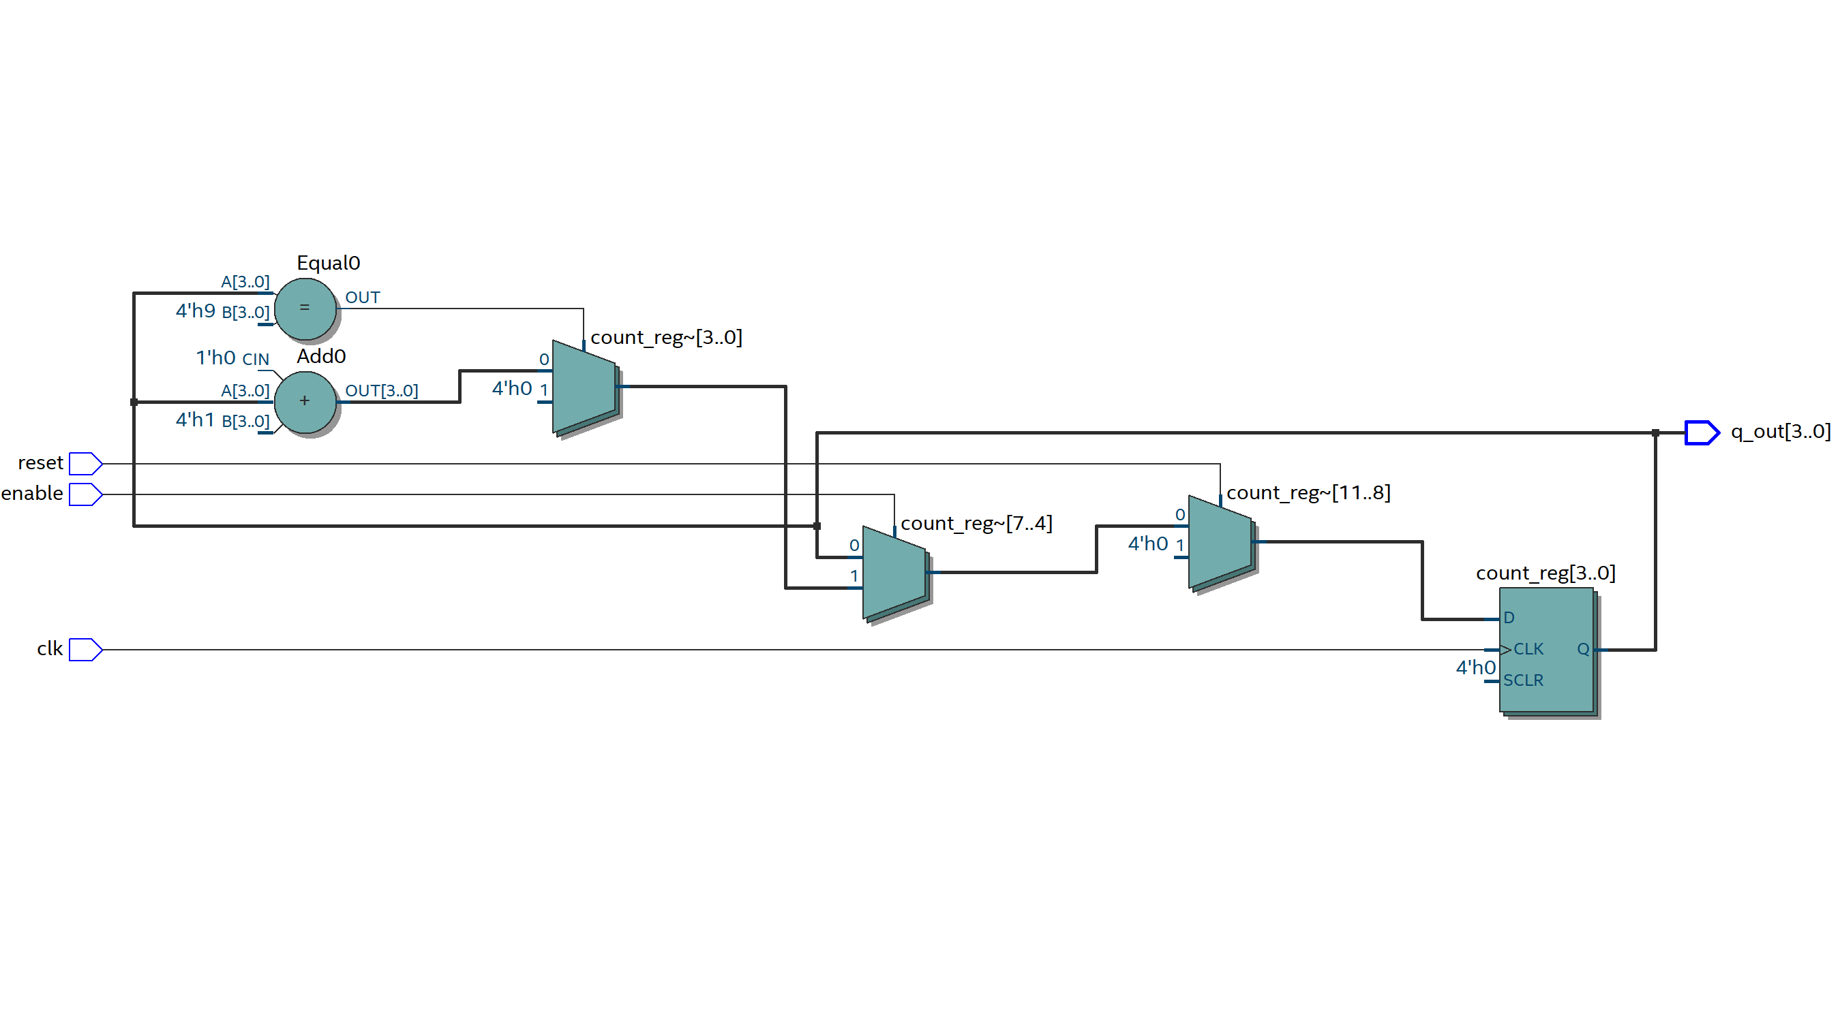
[(C) Insert a screenshot of your functional waveform simulation showing inputs and simulated outputs for at least 10 clock cycles.] (2 points)
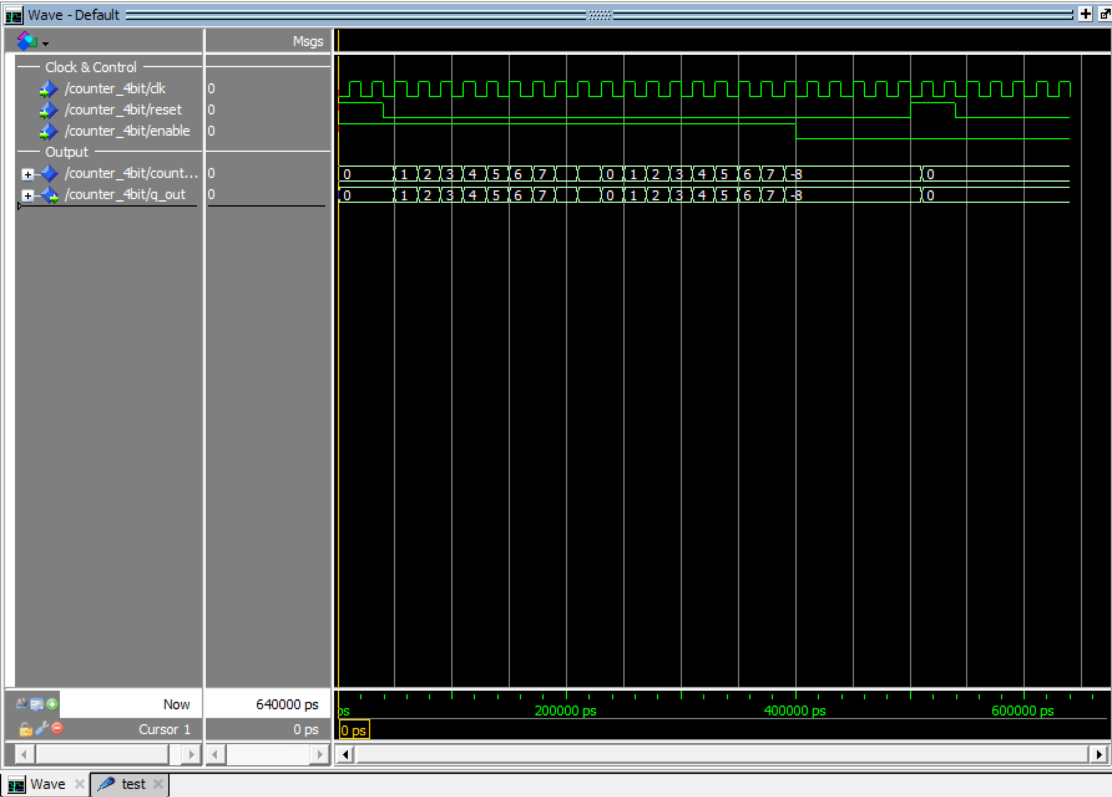

Part II: Clocking Circuitry (20 points)
[(A) Insert a screenshot of your VHDL code for Part II.] (2 points)
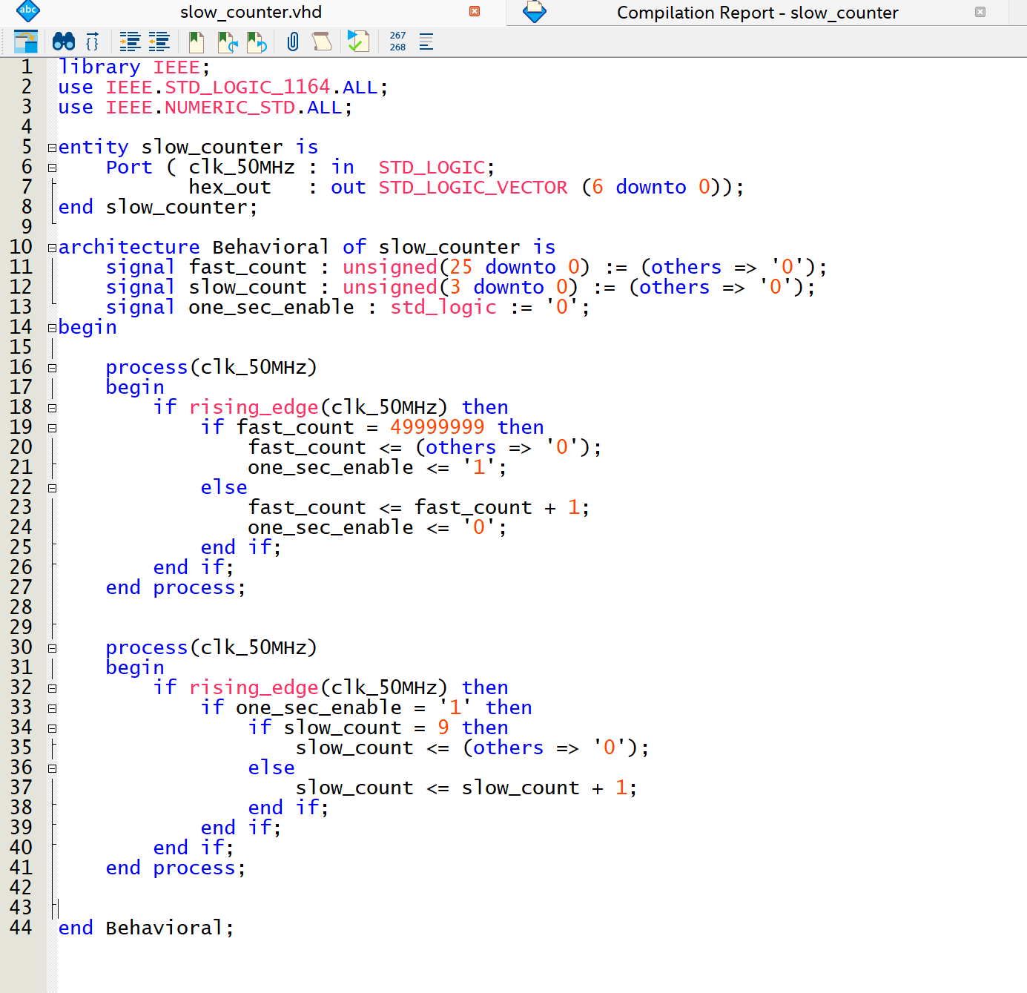
[(B) Demonstrate your circuit to an instructor or TA for the first Lab 10 check-off.] (18 points)

Part III: Rotating Word Display (5 points)
[(A) Insert a screenshot of your VHDL code for Part III.] (5 points)

Part IV: Augmenting the Rotating Display (20 points)
[(A) Insert a screenshot of your VHDL code for Part IV.] (2 points)

[(B) Demonstrate your circuit to an instructor or TA for the second Lab 10 check-off.] (18 points)

[Leave the page unchanged if you are not going to use. Otherwise, specify the problem number you are working on here. Don’t forget to notify “TO BE CONTINUED” in the original problem box]

[Leave the page unchanged if you are not going to use. Otherwise, specify the problem number you are working on here. Don’t forget to notify “TO BE CONTINUED” in the original problem box]

